**Software Development Process**

**Zhongnan li 1931254**

1. **Problem statement:**

1. In the first part of the program, there is a “Menu page”. The program will provide three options for players, which represents “Login”, “Register” and “Exit”. Players can choose one of the three options to choose the functions they want to achieve. Login: When the player chooses to log in, the program will provide the player with a place to log in the user name and password, and can determine whether the entered user name has been registered, and whether the password entered after the registered user name is correct.

Register: When a player chooses to create a new account, the program will provide an interface for the player to register an account. The account registered by the player will be stored in a text file and executed by the system.

Exit: Players can exit the program through this option.

1. In the second part of the program, there is a "Submenu page". The program provides five options to the player, namely, start a new game, view history, clear history, log out and return to the main menu, and log out of the game.

Start a new game: The program will enter the game interface through this option. View history: The program provides an interface that displays the number and time of the player's previous attempts. These are the information recorded in the text file in the same way.

Clear history: The program provides players with an option to clear all attempts and corresponding time.

Back to the main menu: The program provides an option to log out and return to the main menu.

Exit: Players can exit the program through this option.

1. In the third part of the program, there is a “Game page”. In the game interface, a 44 matrix composed of random symbols will appear, which will be turned over after a short display and become a unified symbol "-". The program will also provide the player with a place to input, so that the player can enter two numbers representing the position of the symbol. If the symbols corresponding to the input numbers are the same, the two symbols will appear and remain, and enter the next input. If the symbols are different, the symbols will be displayed briefly and then turned over again. The program will provide the player with two options, continue the game or stop the game. Players can choose to record the number of attempts and time of the game, and at the end of the program will give the option of "whether to record".

4. The program provides options to return to the main menu and close the program in each interface, which greatly facilitates the player's operation.

**2) Analysis**

• **On an input:**

In the entire program, there are more than 10 pieces of information that need to be entered. In the main menu and the submenu interface, there are a total of eight letter options with different meanings that require the player to input twice. For example, enter "a" in the main menu to enter the login interface, and enter "a" in the submenu to enter the game interface. If the player enters a number or letter that is not within the provided range, the player will be re-provided to allow him to enter it again.

In the login and registration interface, there are a total of four places where players need to input, namely two user name input places and two password input places.

In the game interface, players need to enter numbers from 1 to 16 to open the corresponding symbols, and enter two numbers at a time. And when the selection is wrong, the player needs to input “Y” or “N” to decide whether to continue the game, and needs to input “Y” or “N” at the end to decide whether to save the game record.

• **On Outputs:**

In the main menu, the following text will appear to remind the player how to operate.

"Welcome to Find the Pairs. Test your memory: Select frome the following options: a. Login to your account b. Create new account q. Quit Option: ". If you select a, the login interface will appear. If you choose b, the registration interface will appear.

In the sub menu, the following text will appear to remind the player how to operate.

"Hello player! Please select from the following options: a. Start a new Game b. Check your Game history c. Clear Game history d. Back to Menu q. Quit Option: ". If you select a, you will enter the game interface. If you choose b, two columns of information about the number of historical attempts and historical game time will appear. If you choose c, you will still return to the submenu. If you choose d, you will return to the main menu.

In the game interface, there will be two 44 matrices, the first one consists of 16 numbers from 1 to 16, the second one consists of 8 groups of 16 random symbols. Below the matrix, there will be a place for the player to input numbers. If the input is correct, the corresponding two symbols will be opened and displayed on the screen. If you make a mistake, you will be prompted whether to continue the game. At the end of the game, a prompt will appear whether to save the game record.

• **Data structure:**

In this program, there are several types of variables such as string, char, integer and so on. These variables are used to store information or to count or judge the condition of loops.

All input in the program, except option input and coordinate input, are stored in an array that is easy to call. And at the beginning of the program, a structure named User is defined to store the array.

• **Algorithm:**

There are many loops in the program. For instance, the program needs a “do…while” loop to realize the repeating progress of showing the matrix on the screen. Two “switch” loop to determine which function players want to achieve. Several “if…else” is also needed for deciding whether it is the right password.

**3) Design**

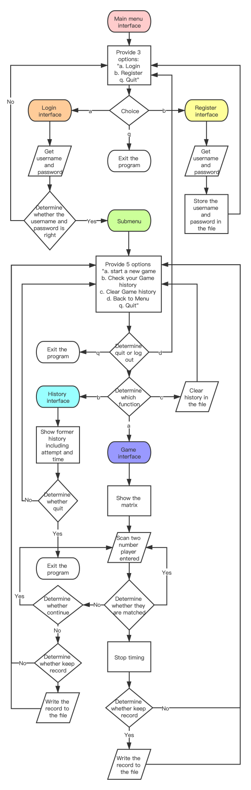

**4) Implementation**

see the C code “1931254_2” with comments.

**5) Testing**

First, after starting the program, the main menu shows off.

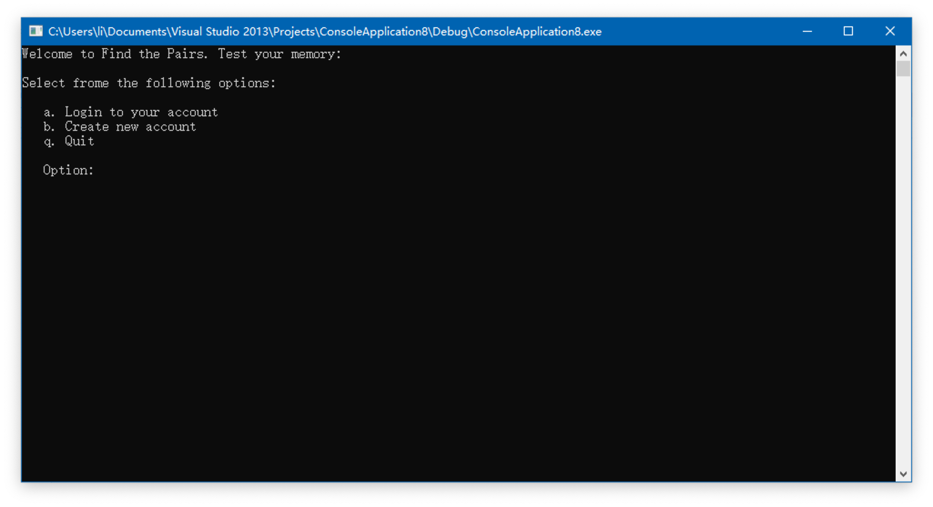

We chose “b” to create a new account.

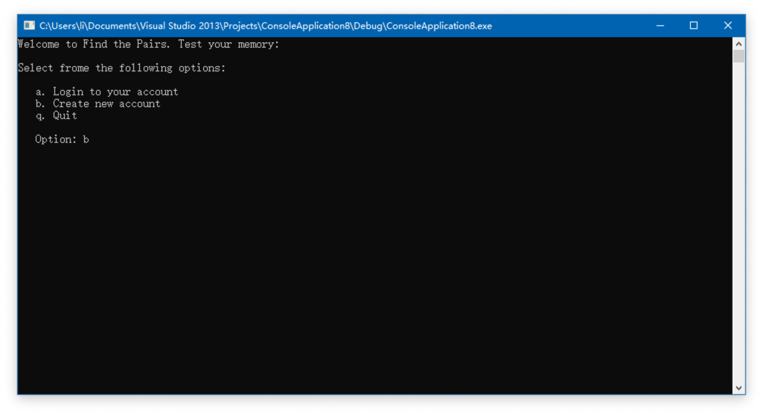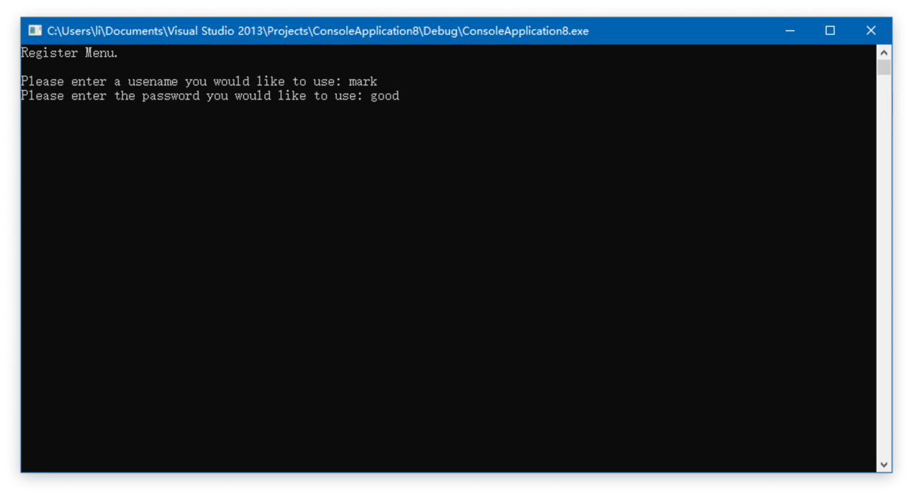

After pressing the “Enter”, we successfully registered an account, and a text file which stores the username and password existed.

文件

At the same time, the program went back to the main menu.



This time, we chose “a”. Then we jumped into the login interface.

We input the username and password which are registered, successfully login.

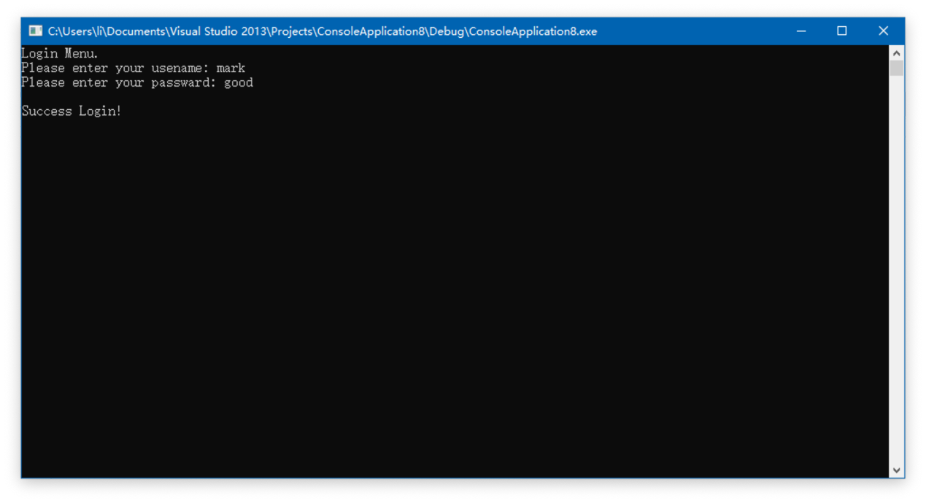

Then the submenu interface showed on the screen.

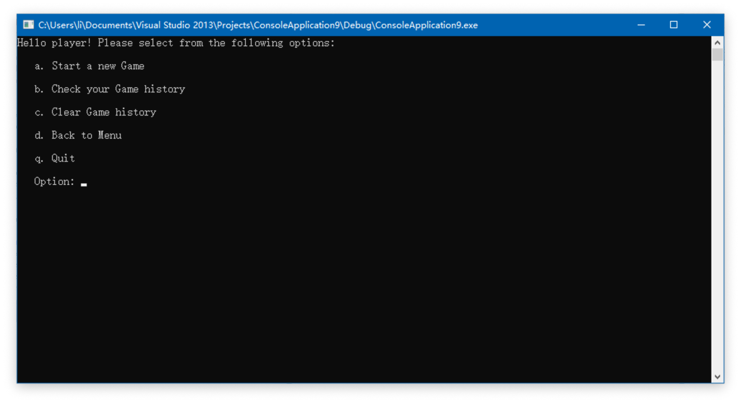

We first checked the history.

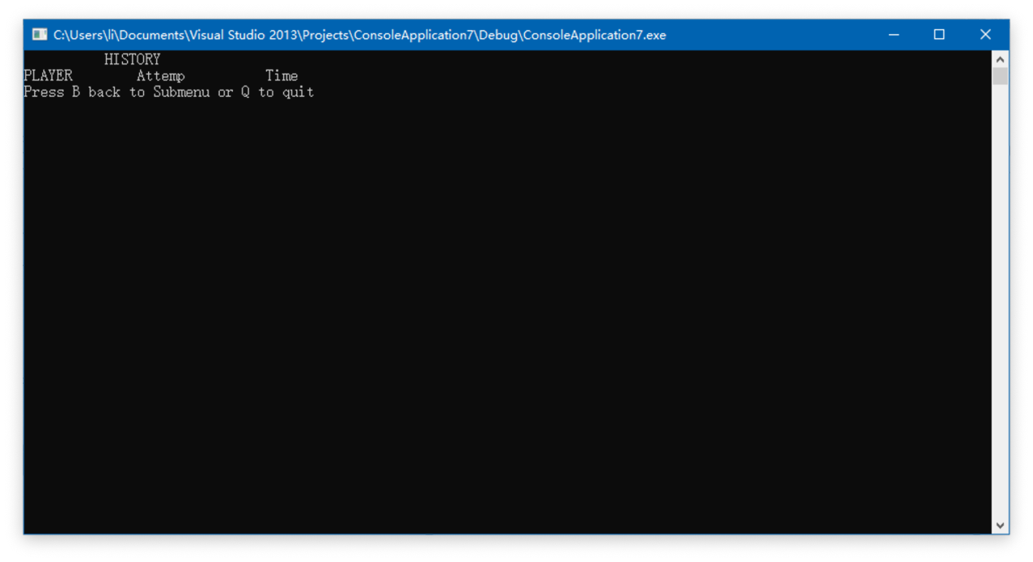

Then we pressed “B” to go back to submenu.

This time, we pressed “a” to start a new game.

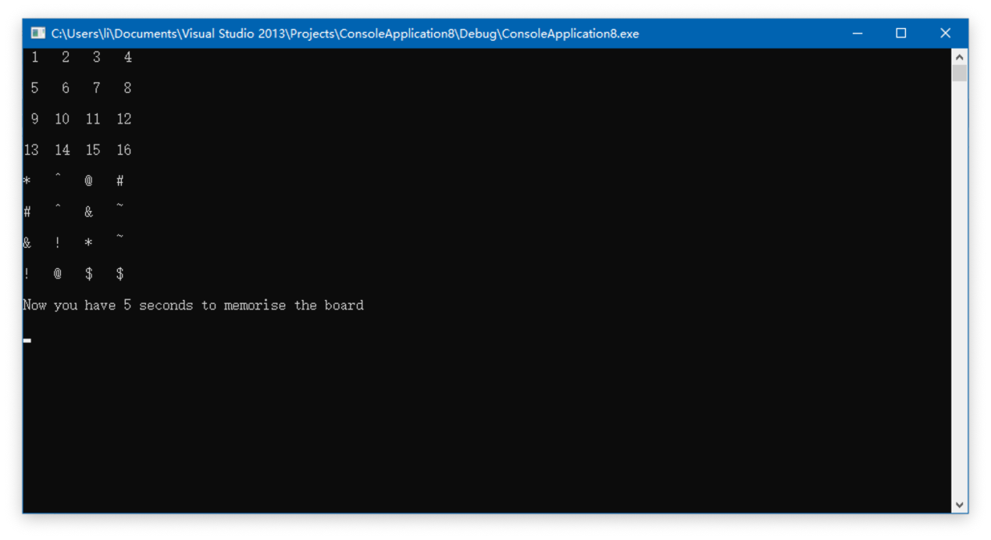

First, all the symbols are displayed for five seconds, and then turned over and become the following:

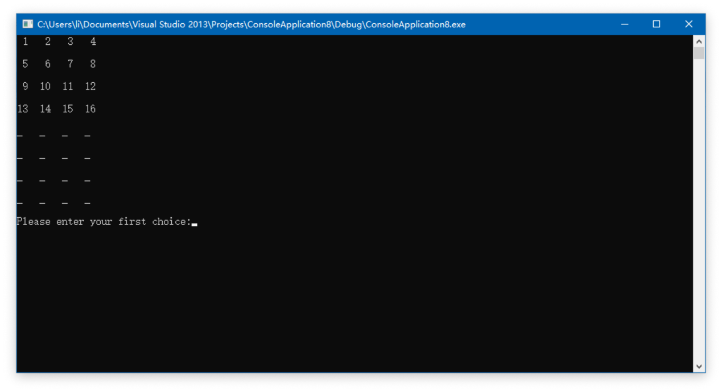

We first entered a set of correct data and got this feedback.

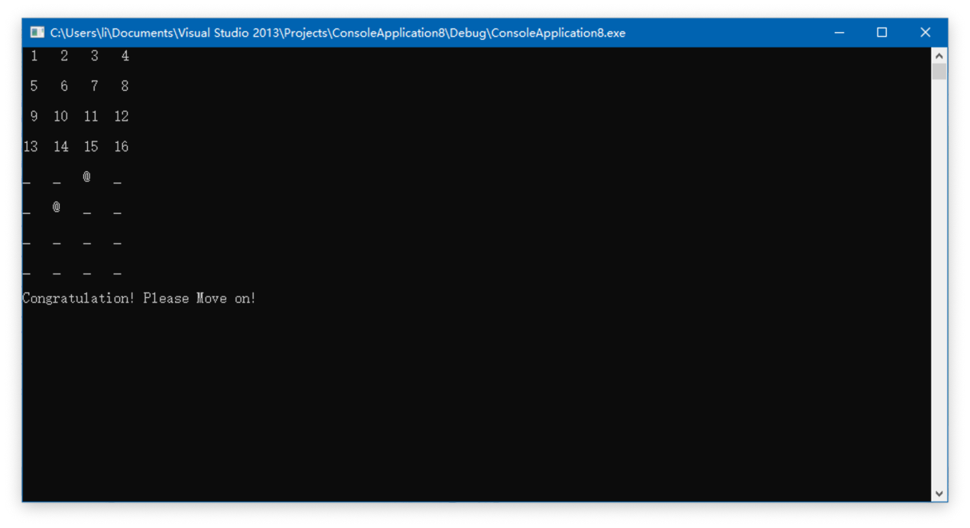

Then we went on to enter a set of wrong data.

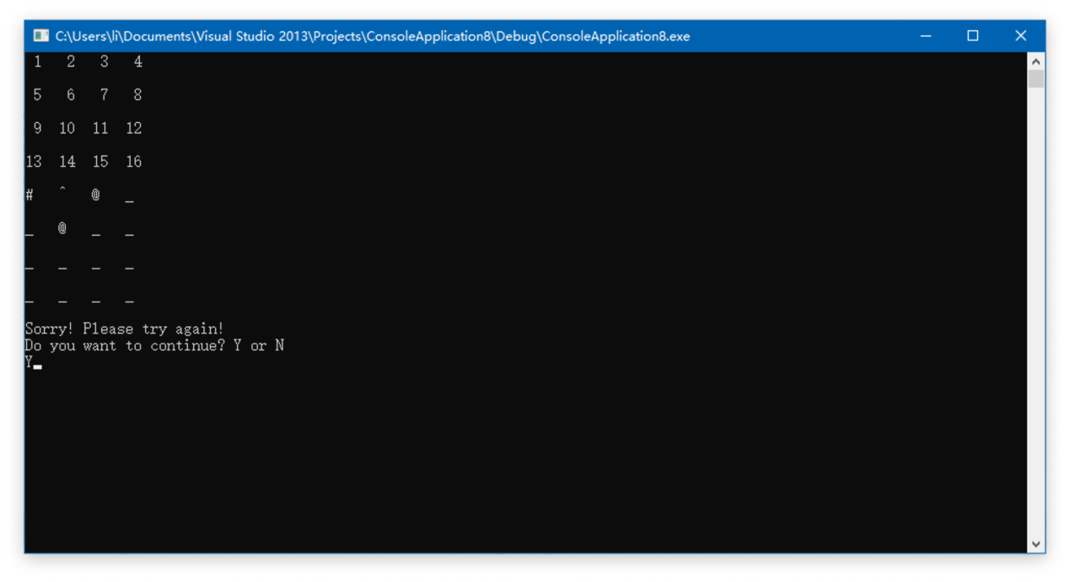

We chose continue the game.

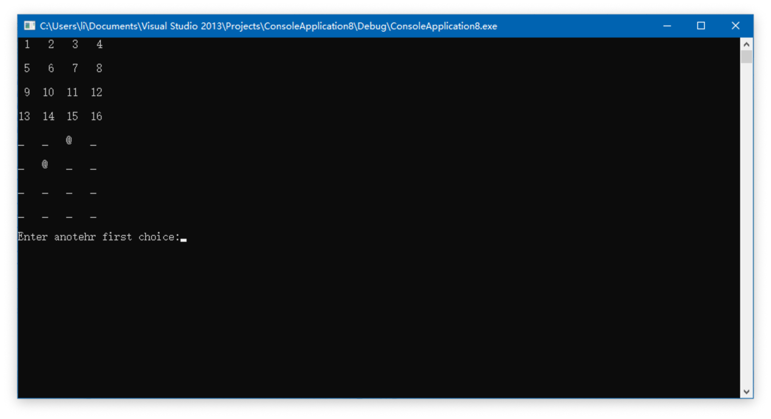

If we chose wrong answer, and pressed “N”.

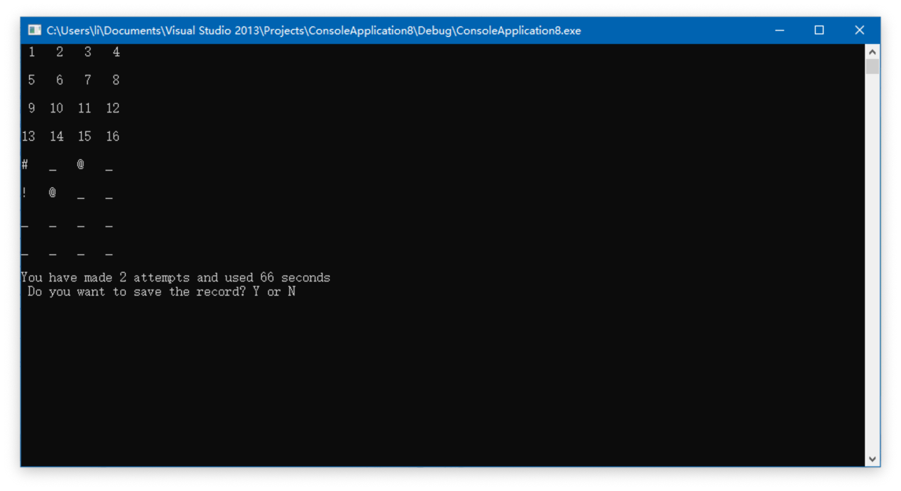

At this interface, whether we choose to save record or not, we will return to the submenu.

When we finish all the matches, an interface will present like this.

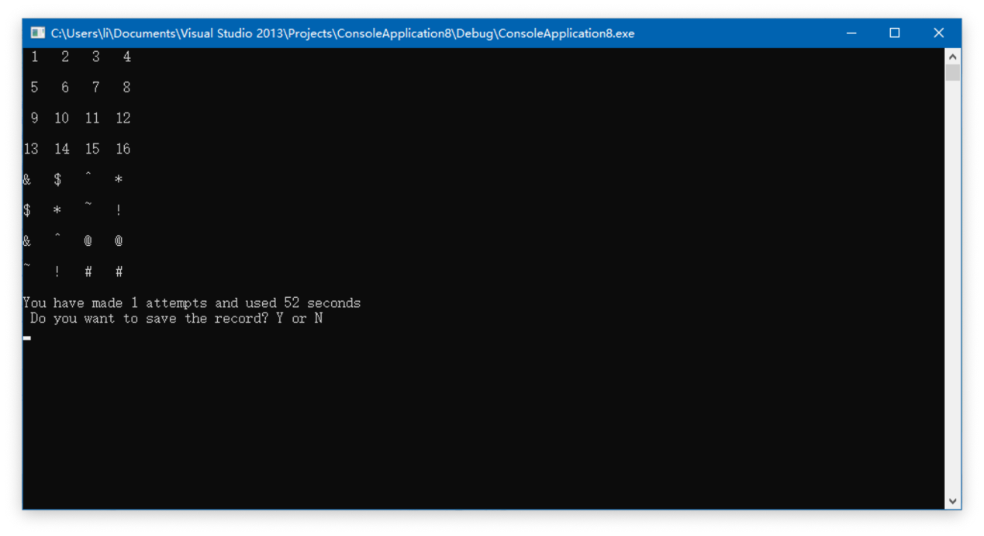

We can choose whether save the record.

We saved the record.

As the history interface shows, we have one record like this.

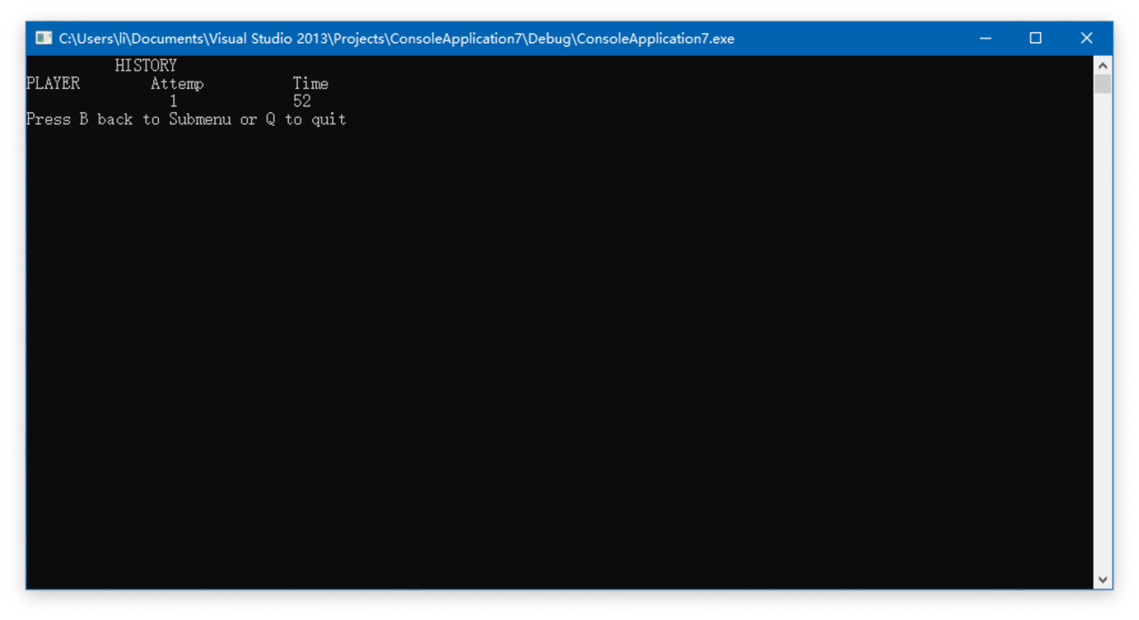

Then we tried other illegal input. At the menu interface, we input a different letter.

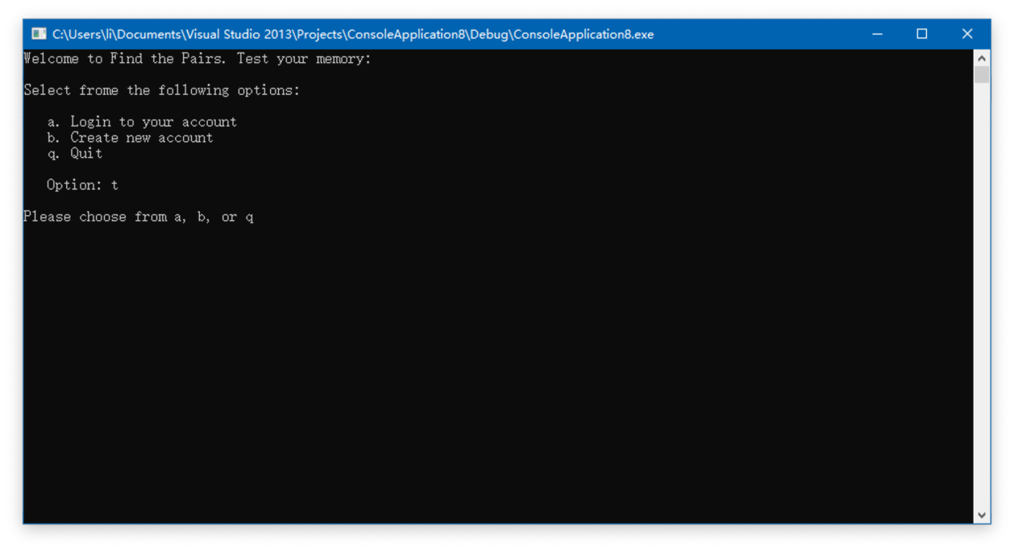

At the login interface, we input wrong password.

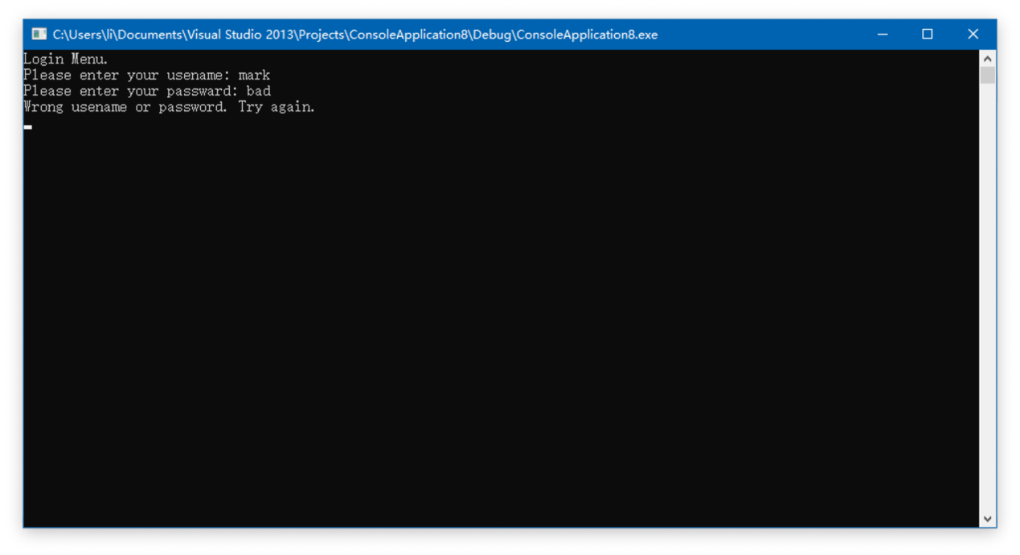

At game interface, we input wrong number.

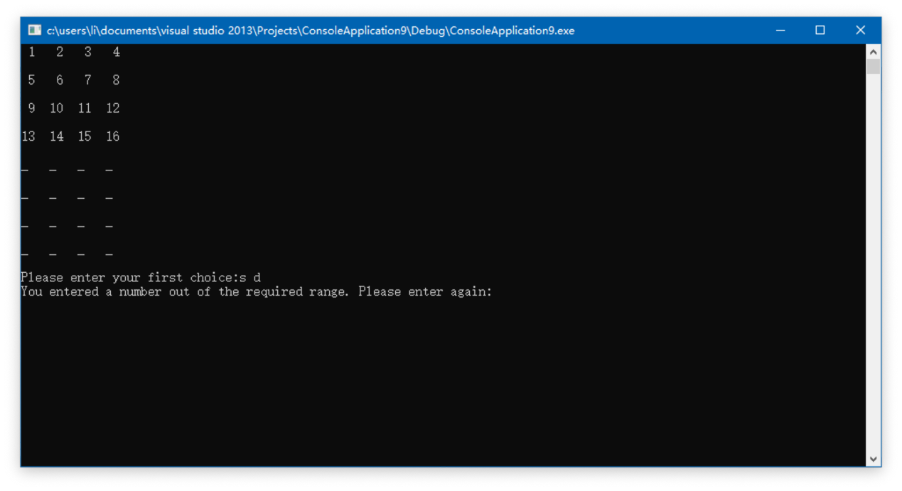

That’s all we tested.